**Question 01**

Command:ipconfig

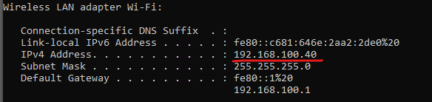

**Question 02**

Command: getmac /v

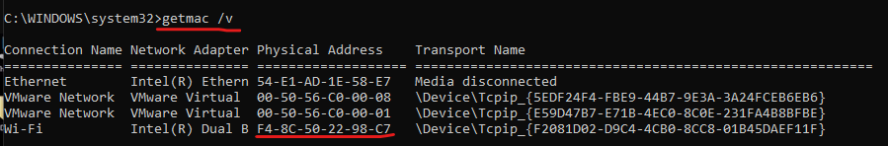

Yes dhcp server is on because its necessary to find ip addresses.

**Question 03**

Command: hostname



**Question 04**

Reason: The computer may not have a internet connection or maybe hostname is incorrect.

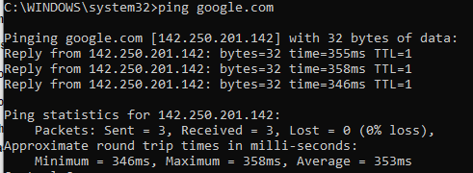

**Question 05**



**Question 06**

Command: net share

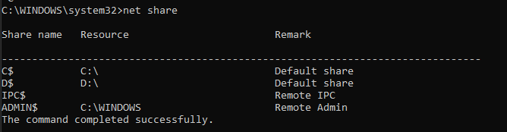

**Question 07**

Command: arp -a

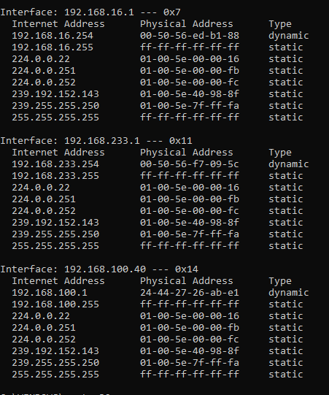

**Question 08**

**Question 09**

Command: ipconfig

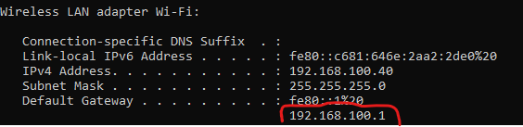

**Question 10**

Command: tracert 8.8.8.8

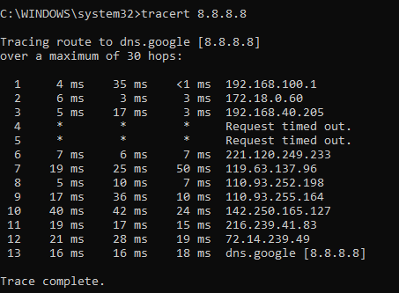

**Question 11**

The name “blue machine” isn’t registered with a dns server.

**Question 12**

I would use an ethernet cable because it has RJ45 connectors and it is designed to transmit data quickly over short distances.

**Question 13**

**Question 14**

**Question 15**